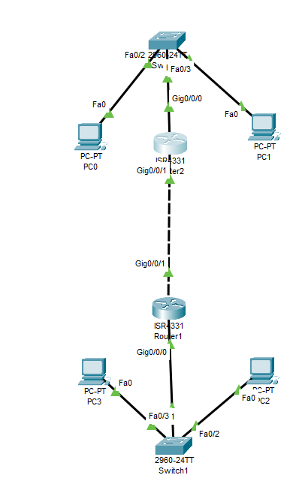

Doing configuration to this network we need the following :

First do ip add to the devices and for the router it must have 2 ips (local ,wan)

First for the connection between the local which is between the device s and must be in the same range it means

Device 0 ip can be 192.168.100.2 subnet 255.255.255.0

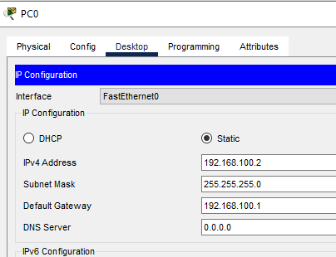

Device 1 ip can be 192.168.100.3subnet 255.255.255.0

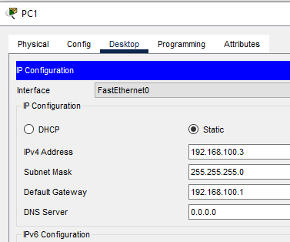

Then the router io for the local connection can be 192.168.100.1 255.2555.255.0

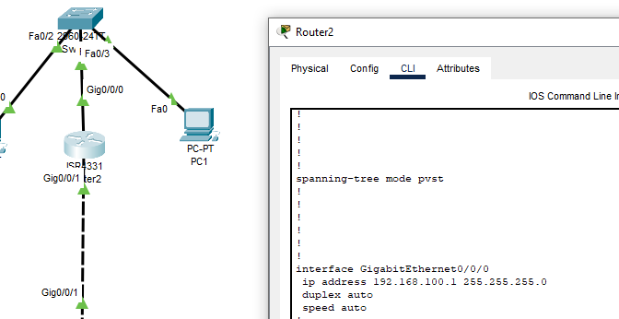

For the wan ip dor te router it will be 192.168.1.1 255.255.255.0

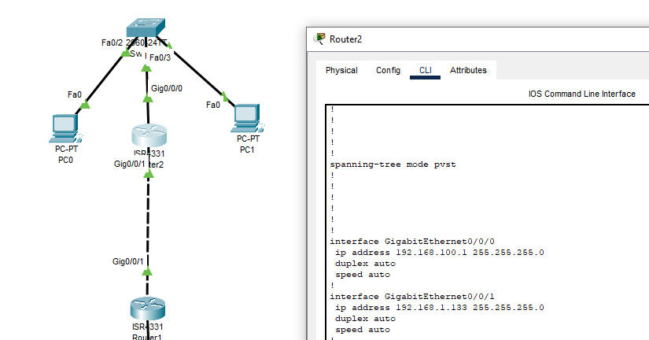

So here the wan router ip must be in the different range of the local .it canot be with the same range like (192.168.100.77) cause the range of the loca is from

(192.168.100.0

192.168.100.255)

The first 3 octet is static the

So it can be 192.168.1.133 255.255.255.0

Now for the device number 2 and 3

It is okay it can take the same ip as device 0 and 1 because it is local but if its wan we can not

Device 2 ip can be 192.168.100.2 subnet 255.255.255.0

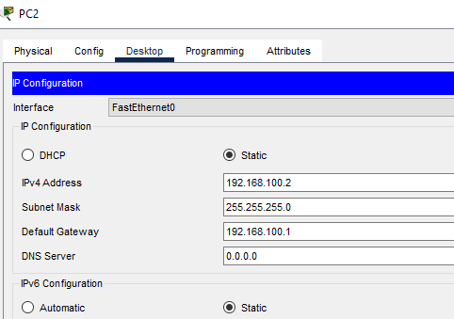

Device 3ip can be 192.168.100.3 subnet 255.255.255.0

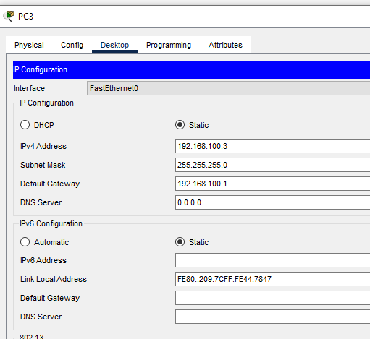

Then the router io for the local connection can be 192.168.100.1 255.2555.255.0

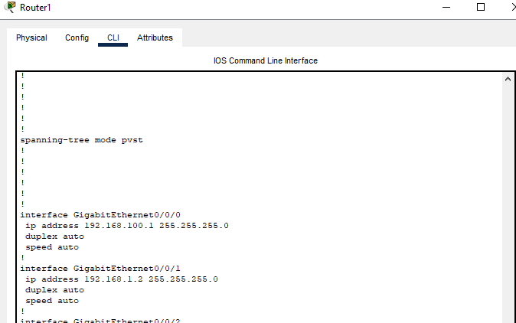

So here the wan router ip must be in the different range of the local .it canot be with the same range like (192.168.100.77) cause the range of the loca is from

(192.168.100.0

192.168.100.255)

The first 3 octet is static the

So it can be 192.168.1.2 255.255.255.0 (must be with the same range with router wan ip of the router wan in the first ,so that the connection will be establish)